
Media Release
June 2026
For immediate release
Contact: Michelle Palacios
Oregon Blueberry Commission
503.364.2944 • michelle.palacios@bci-mgmt.com
oregonblueberry.com
Oregon Blueberry Harvest Underway
as Growers Anticipate Another Strong Season
Fresh, locally grown blueberries deliver economic impact, export success
and summer flavor
Fresh Oregon-grown blueberries are reaching peak season, bringing consumers one of summer’s most anticipated and nutritious fruits while contributing significantly to the state’s agricultural economy.
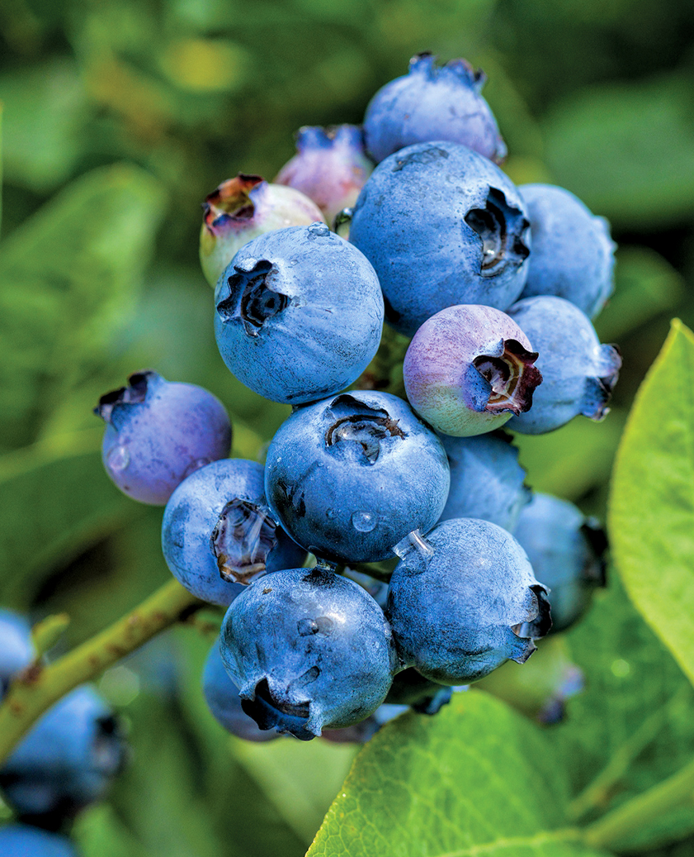
Harvest begins in late June and continues through September, with growers across the state preparing for another abundant crop. Oregon remains one of the nation’s leading blueberry-producing states. In 2025, Oregon growers harvested 172.3 million pounds of blueberries, reinforcing the crop’s position among the state’s top 10 most valuable agricultural commodities.
Oregon’s combination of ideal growing conditions, innovative farming practices and dedicated growers has earned the state a reputation for producing premium-quality blueberries with exceptional flavor, size and sweetness. Farms range from large-scale operations that export fruit around the world to family-owned farms that welcome visitors for on-farm sales and u-pick experiences.
“Oregon blueberry growers create a powerful economic force for our state,” said Michelle Palacios of the Oregon Blueberry Commission. “Oregon growers not only produce a world-renowned blueberry, but they also stimulate business, support rural communities and contribute greatly to our economy.”
Oregon is also a leader in blueberry exports, supplying fruit to markets throughout Asia and Southeast Asia, including Vietnam, Singapore, Malaysia, the Philippines, Japan and South Korea. While Oregon blueberries enjoy global demand, local consumers can find fresh berries close to home at grocery stores, farmers markets, farm stands and u-pick farms throughout the harvest season.
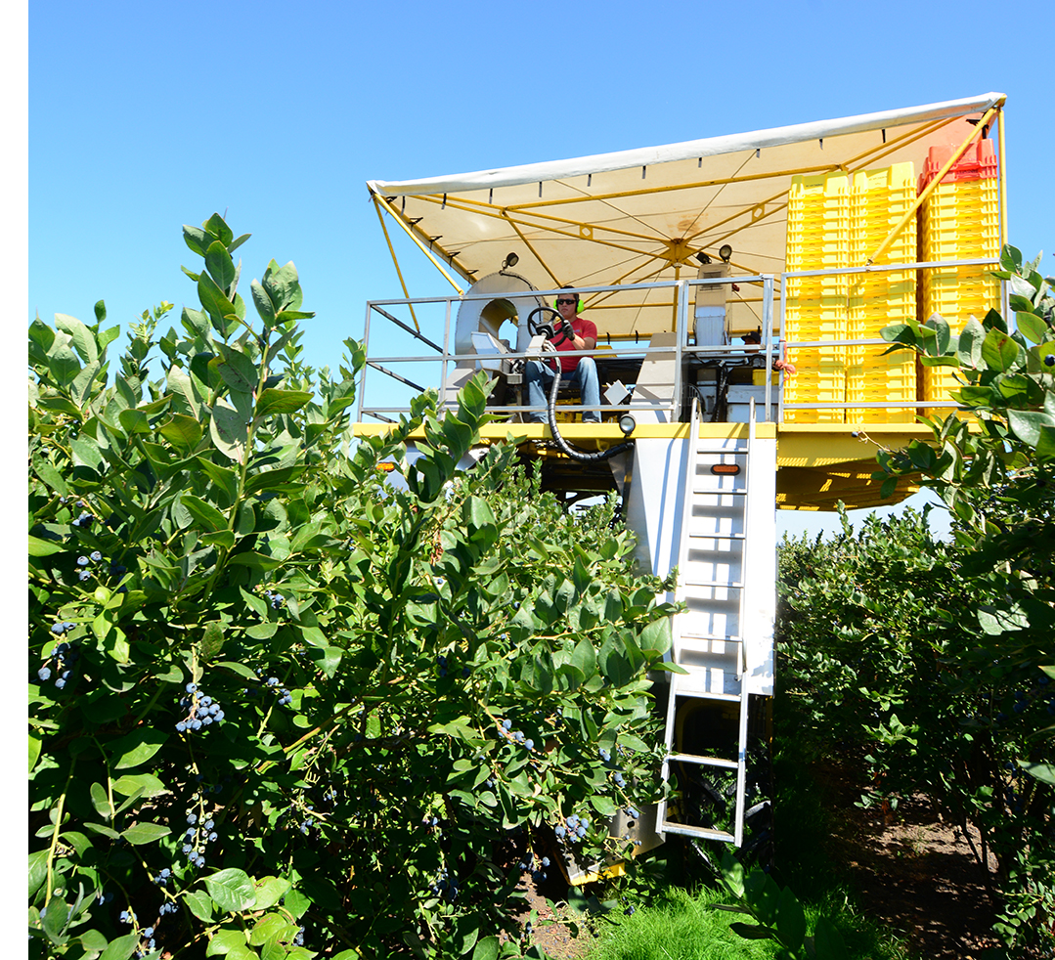
In addition to their popularity and flavor, blueberries continue to attract health-conscious consumers. Blueberries are certified Heart-Healthy by the American Heart Association and provide a range of nutritional benefits, including antioxidants, vitamin C and dietary fiber. One cup contains just 80 calories, 15 percent of the daily recommended value of vitamin C and 11 percent of the daily recommended value of fiber.
“Oregon blueberries are so delicious and nutritious that people all over the world want them,” Palacios said. “Fortunately, Oregonians only have to travel to their local store, farmers market, farm stand or u-pick farm to enjoy them. As consumers become more discerning about quality, Oregon is well positioned with exceptional fruit size, sweetness and freshness.”

Oregon Blueberries by the Numbers
• 172.3 million pounds harvested in 2025
• Ranked among Oregon’s Top 10 most valuable agricultural commodities
• Exported to major markets throughout Asia and Southeast Asia
• Certified Heart-Healthy by the American Heart Association
• One cup contains 80 calories, 15% DV of Vitamin C and 11% DV of fiber

Story Ideas for Media
• Oregon’s growing role in the global blueberry marketplace
• The economic impact of blueberry production across Oregon
• Local u-pick farms and agritourism opportunities
• Summer recipes, nutrition trends and blueberry-inspired foods
• Meet the growers behind Oregon’s blueberry industry
For additional information about Oregon’s blueberry industry, harvest statistics, nutrition information or a directory of u-pick farms, contact the Oregon Blueberry Commission or visit OregonBlueberry.com.


Michelle Palacios
Oregon Blueberry Commission
P.O. Box 3488, Salem, Oregon 97302
503.364.2944 • email: michelle.palacios@bci-mgmt.com
www.oregonblueberry.com

