**Media Release  
June 2024  
  
For immediate release**Contact: Bryan Ostlund  
Oregon Blueberry Commission  
503.364.2944 • bryan@ostlund.com   
**oregonblueberry.com**

**The Most Delicious Time of Year -   
Fresh Oregon Blueberry Season is Here**

**Fresh Oregon-grown blueberries** are one of the joys of summer and right now they’re at the peak of perfection. Blueberries are easy, delicious, versatile, healthy and more in demand than ever. Thanks to Oregon’s skilled and passionate growers, this season will yield another bountiful harvest and will have a great economic impact on the state we love.

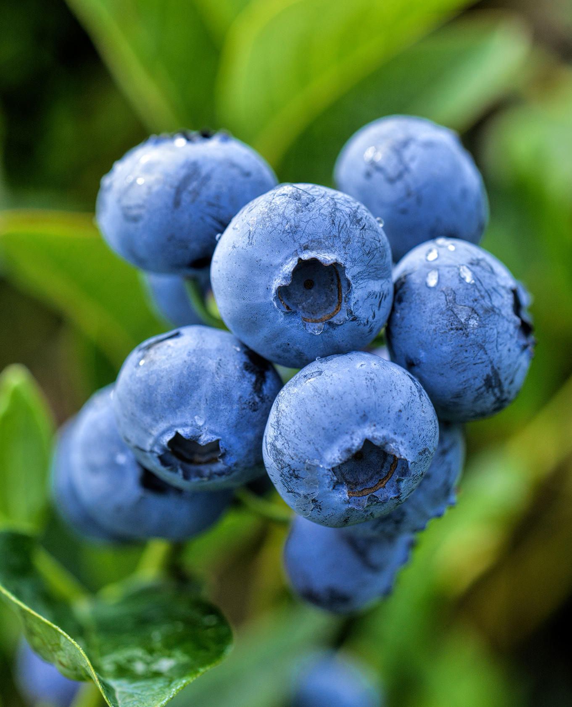Oregon blueberries are ranked among the top ten of the most valuable agronomical commodities statewide. With a harvest potential of more than 170 million pounds, Oregon ranks among the top producing states in the nation for blueberry production.

Oregon’s ideal growing conditions and dedicated growers have earned Oregon a reputation for producing the best quality fruit with the highest crop yields in the nation. Oregon farms range from large operations that ship their crop worldwide, to small family farms offering on-farm sales.

Oregon is a leader in the global export of United States blueberries including countries such as Vietnam, Singapore, Malaysia, the Philippines, Japan and South Korea. Fortunately, Oregonians only have to travel to their local store, farmers market, farm stand or u-pick farm to enjoy.   
  
Harvest starts in late June and continues into September.

**“Blueberries give you confidence you’re doing something right in every bite. Whether you’re looking for convenient, tasty ways to inspire healthy eating, seeking a versatile and refreshing grab-and-go snack or searching for the coolest cocktail or unexpected food pairings, blueberries are your go-to,**” said Bryan Ostlund of the Oregon Blueberry Commission.“With consumers more discerning about their blueberries, Oregon is well positioned with exceptional fruit size and sweetness.”

*continued*

Oregon blueberries add a boost of flavor and health in every handful. They are a **convenient, tasty way to inspire healthy eating and a** delicious way to energize everyday meals.

Oregon Blueberries are an **easy, nutritious solution to eating well**. One cup of blueberries contains 80 calories, 15 percent daily vitamin C, 11 percent daily fiber and other essential nutrients to boost the immune system. They are certified as a heart-healthy food by the American Heart Association and contain natural compounds that help the brain stay strong.

**If you think you’ve tried all the blueberry recipes out there, think again. Picking up blueberries can be a fun adventure – they taste great, they’re versatile and it doesn’t take a master chef to create creative ways to eat them. There’s no wrong way to enjoy with blueberries.**

This season will yield another bountiful harvest, will have a great economic impact on the state we love and will bring smiles to consumers. It’s a great story.

Additional information on the Oregon blueberry industry, list of u-pick farms, harvest statistics, marketing or blueberry nutrition can be found at **oregonblueberry.com**.



Bryan Ostlund  
Oregon Blueberry Commission  
P.O. Box 3366, Salem, Oregon 97302  
503.364.2944 • email: bryan@ostlund.com   
www.oregonblueberry.com

