Media Release
July 2023
For immediate release
Contact: Bryan Ostlund
Oregon Blueberry Commission
503.364.2944 • bryan@ostlund.com
oregonblueberry.com
Ripe Right Now -
Fresh Oregon Blueberry Season is Here
Colorful, healthy and delicious, fresh Oregon-grown blueberries are one of the joys of summer and right now they’re at the peak of perfection. Thanks to Oregon’s skilled and passionate growers, this season will yield another bountiful harvest and will have a great economic impact on the state we love.
Oregon blueberries rank #10 of the most valuable agronomical commodities statewide, valued at $171.1 million dollars. With a harvest potential of more than 170 million pounds, Oregon ranks among the top producing states in the nation for blueberry production.
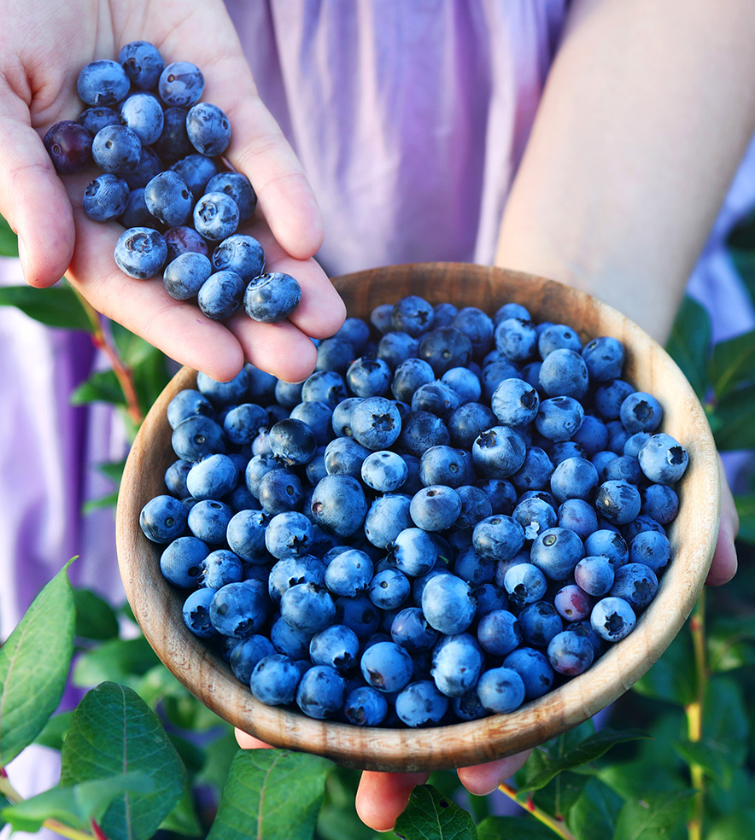
“The over 320 blueberry growers in Oregon create a powerful financial force,” said Bryan Ostlund of the Oregon Blueberry Commission. “Oregon growers not only produce a world-renowned blueberry, but they also stimulate business and contribute greatly to our economy.”
Harvest starts in late June and continues into September.
Oregon’s ideal growing conditions and dedicated growers have earned Oregon a reputation for producing the best quality fruit with the highest crop yields in the nation. Oregon farms range from large operations that ship their crop worldwide, to small family farms offering on-farm sales.
Oregon has been a leader in the international export market. Continued growth of Southeast Asia including Vietnam, Singapore, Malaysia, the Philippines and Chinese markets is promising.
“Oregon Blueberries are so delicious and nutritious that people all over the world want them. Fortunately, Oregonians only have to travel to their local store, farmers market, farm stand or u-pick farm to enjoy,” Ostlund said. “With consumers more discerning about their blueberries, Oregon is well positioned with exceptional fruit size and sweetness.”
continued
Oregon blueberries add a boost of flavor and health in every handful. They are a convenient, tasty way to inspire healthy eating and a delicious way to energize everyday meals.
Oregon Blueberries are an easy, nutritious solution to eating well. One cup of blueberries contains 80 calories, 15 percent daily vitamin C, 11 percent daily fiber and other essential nutrients to boost the immune system. They are certified as a heart-healthy food by the American Heart Association and contain natural compounds that help the brain stay strong.
If you’re interested in additional information on the Oregon blueberry industry, list of u-pick farms, harvest statistics, marketing or blueberry nutrition, just give us a call or visit oregonblueberry.com.
Simple, healthy and delicious, fresh Oregon blueberries are one of summer’s biggest small pleasures. This season will yield another bountiful harvest, will have a great economic impact on the state we love and will bring smiles to consumers. It’s a great story.
Bryan Ostlund
Oregon Blueberry Commission
P.O. Box 3366, Salem, Oregon 97302
503.364.2944 • email: bryan@ostlund.com
www.oregonblueberry.com
