Media Release
July 2022
For immediate release
Contact: Bryan Ostlund
Oregon Blueberry Commission
503.364.2944 • bryan@ostlund.com
oregonblueberry.com
Grab a Boost of Blue -
Fresh Oregon Blueberry Season is Here
Thanks to Oregon’s skilled and passionate growers, this season will yield another bountiful harvest and will have a great economic impact on the state we love.
Among the top producing states in the nation for blueberries, Oregon has a harvest potential of more than 170 million pounds. Oregon growers provide an annual economic impact to Oregon estimated to be more than $375 million.
With a reputation for producing the best quality fruit with the highest crop yields, Oregon blueberry growers are having a positive economic impact in our communities. Oregon farms range from large operations that ship their crop world-wide, to small family farms offering on-farm sales.
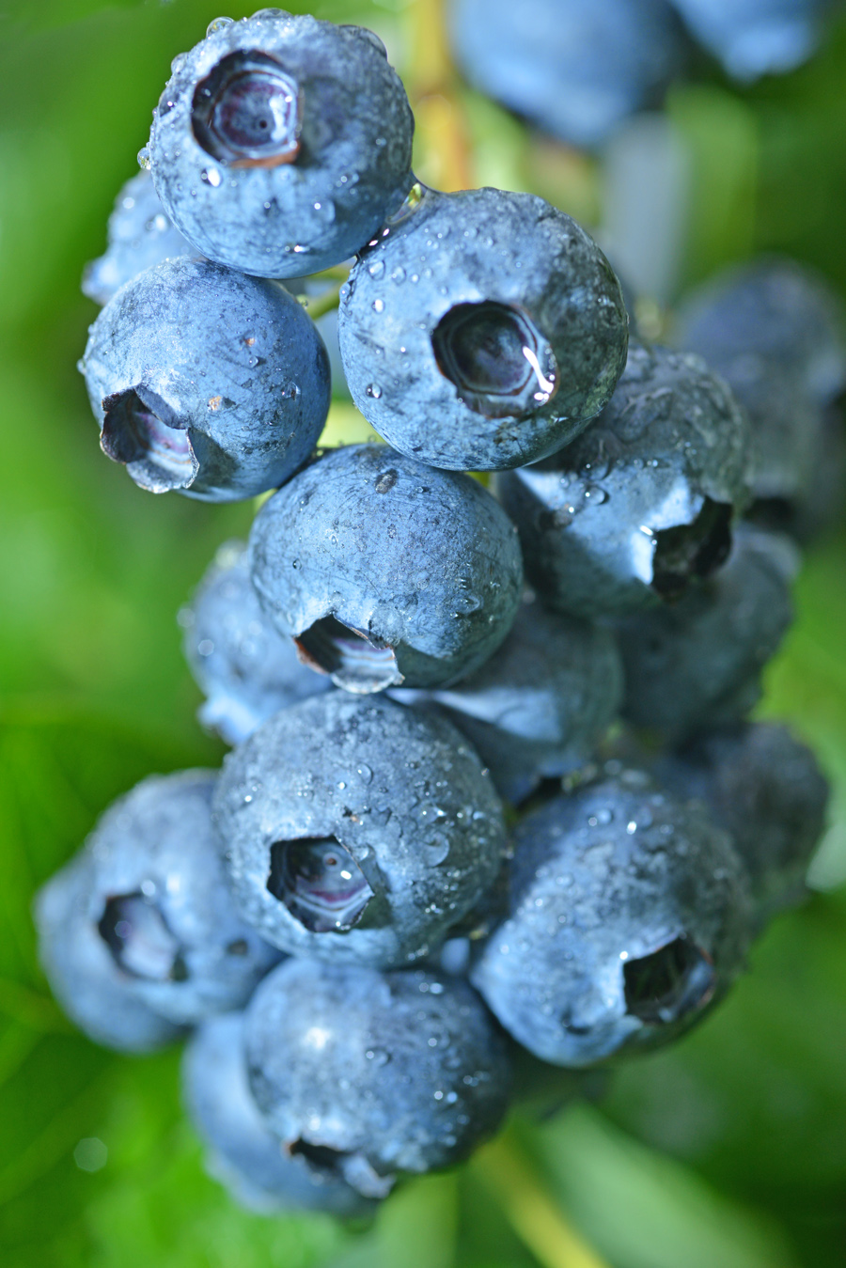
“The over 350 blueberry growers in Oregon create a powerful financial force,” said Bryan Ostlund of the Oregon Blueberry Commission. “Oregon growers not only produce a world-renowned superfood, but they also stimulate business and contribute greatly to our economy.”
It’s estimated that 3,700 full-time equivalent jobs are created and sustained by Oregon blueberry growers each year, with $140 million in labor income generated by the business activities of growers.
In addition to the domestic market, the international market remains optimistic for exports. Continued growth of Southeast Asia including Vietnam, The Philippines and Chinese markets, which opened recently, is promising. Buyers in Singapore and Malaysia are also looking to import Oregon produced blueberries.
“Oregon Blueberries are so delicious and nutritious that people all over the world want them. Fortunately, Oregonians only have to travel to their local store, farmers market, farm stand or u-pick farm to enjoy,” Ostlund said. “With consumers more discerning about their blueberries, Oregon is well positioned with exceptional fruit size and sweetness.”
continued

Blueberries are a convenient and delicious way to energize everyday meals. Grab them by the handful or add excitement to your favorite backyard picnic and summer grilling recipes.
Oregon Blueberries are also known for their incredible health benefits. One cup of blueberries contains 80 calories, 15 percent daily vitamin C, 11 percent daily fiber and other essential nutrients to boost the immune system. They are certified as a heart-healthy food by the American Heart Association and contain natural compounds that help the brain stay strong.
Harvest starts in late June and continues into September.
If you’re interested in additional information on the Oregon blueberry industry, harvest, marketing or blueberry nutrition, just give us a call or visit www.oregonblueberry.com.
Fresh Oregon-grown Blueberries are one of the joys of summer and right now they’re at the peak of perfection. Thanks to Oregon’s skilled and passionate growers, this season will yield another bountiful harvest and will have a great economic impact on the state we love. It’s a great story.
Bryan Ostlund
Oregon Blueberry Commission
P.O. Box 3366, Salem, Oregon 97302
503.364.2944 • email: bryan@ostlund.com
www.oregonblueberry.com

